Connect MySQL to PowerBI

Note : Step 1 and step 2 needs to be followed if installation not done.

Step 1 Download & Install
- Download and install Power BI Desktop
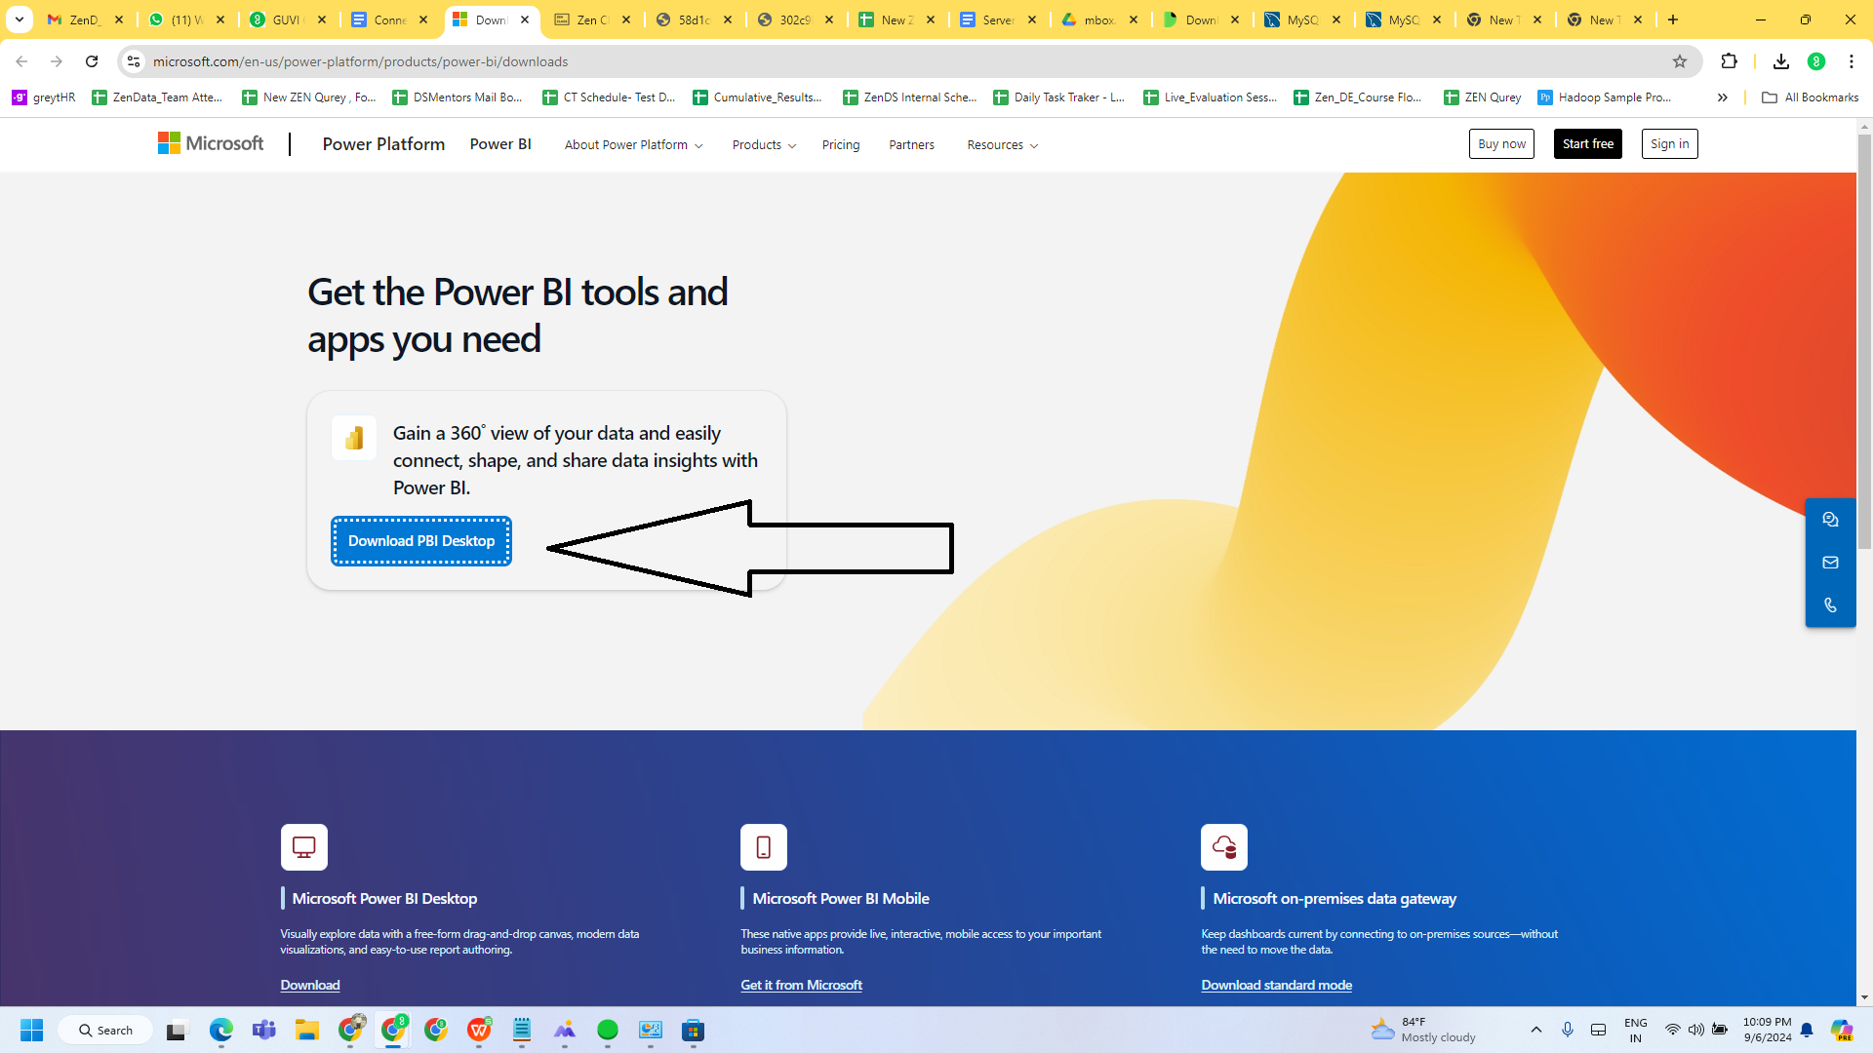
- https://dev.mysql.com/downloads/connector/odbc/
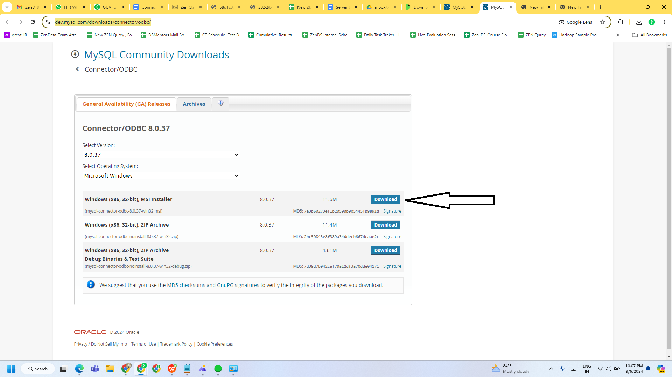

- Download and install the MySQL connector
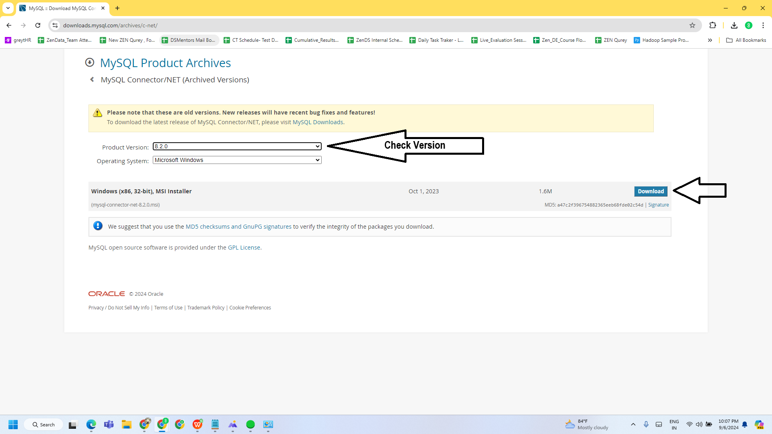

Step 2 : Restart your Laptop

Step 3 - Get Data
In Power BI Desktop, click Get Data then choose the More option at the bottom:
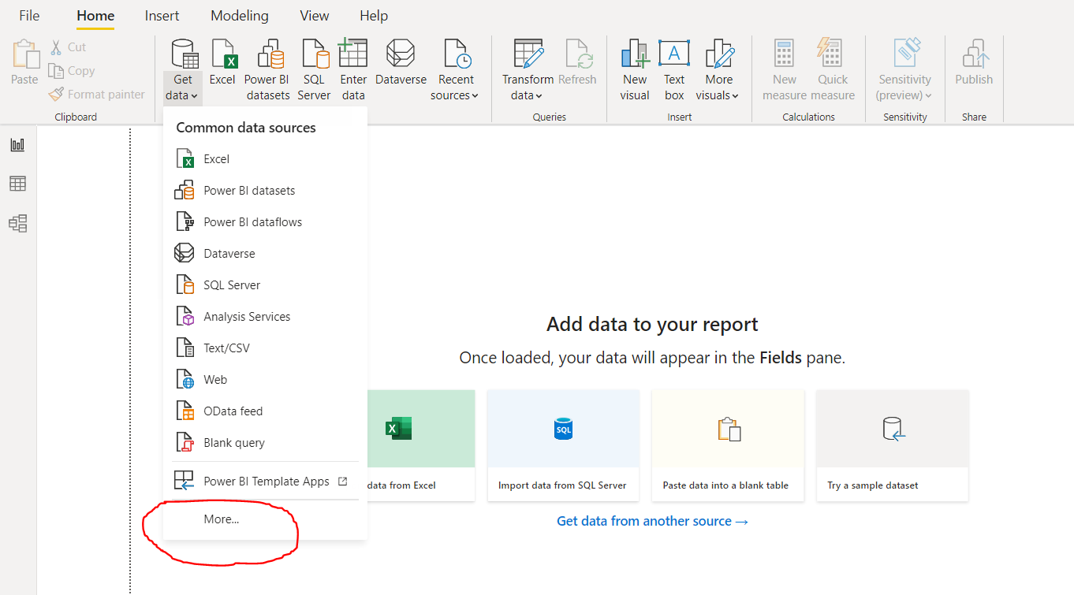

Step 4 - Choose MySQL
Click the “Database” option on the left, then choose MySQL database.

Step 5 - Enter DB Info
Under “Server,” enter the hostname of your MySQL database.
Note : localhost for local installed mySQL
Under “Database”, provide the database to connect to.
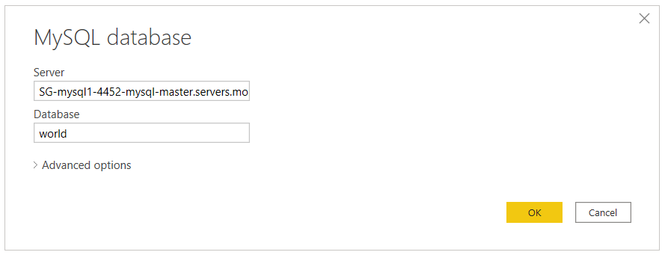

Step 6 - Enter Authentication Credentials
Select the Database authentication type and input your MySQL credentials in the User name and Password boxes.
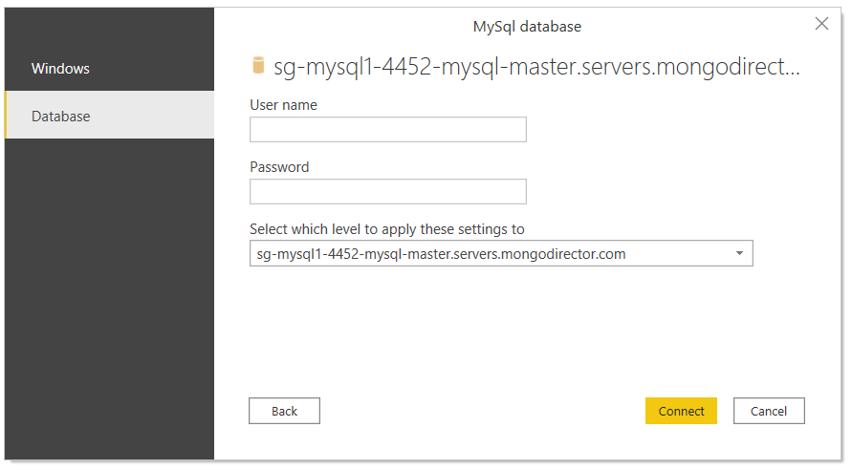

Step 8 - Select Data
In the "Navigator" window, select the data you require, then either load or transform the data.
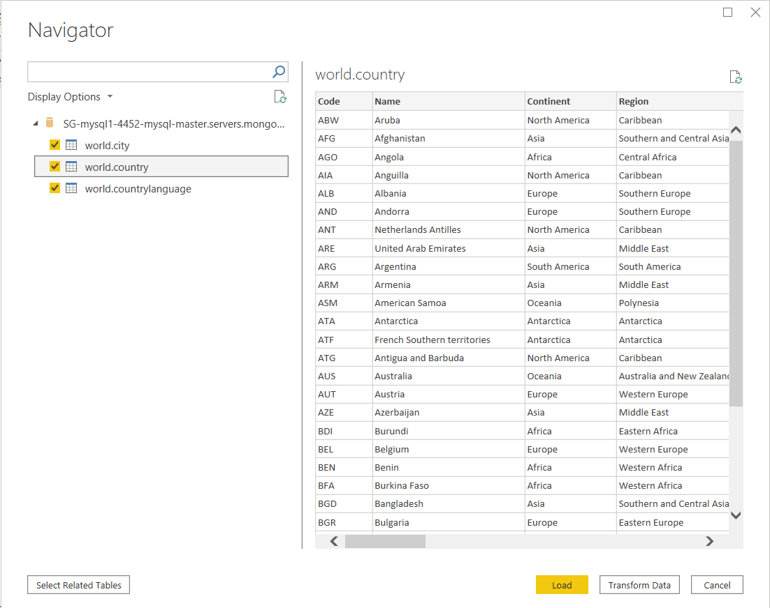
After this, you're all done! You have now used the most straightforward way to connect PowerBI to a MySQL deployment.

